Scrum Team Sprint Events Schedule

1. **Download a copy of the** [**Scrum Team Sprint Events Schedule**](http://ilink/its/agile/Agile%20Learning%20Center%20Document%20Library/AFS%20Materials/Scrum%20Events%20Schedule%20Workshop/Sprint%20Planning%20Calendar.docx)**.**   
   This schedule assumes a two-week sprint
2. **Review the timing cycle for Scrum Events.**   
   See the diagram below
3. **Based on a two week sprint pick start and end dates for the team’s sprint.**A two week sprint should be about 10 business days. However, there needs also to be time outside the sprint time box for planning, review, and retrospective meetings.
4. **Pick a time for the daily scrum meeting and add it to the**Keeping in mind that the Daily Scrum should happen at the same time every day, find a time that best supports the Daily Scrum delivering on its inherent value. The value the Daily Scrum meeting delivers to the team is confirmation that the entire team is making progress toward the Sprint goal and that any blockers to that progress are removed.
5. **Schedule the Sprint Review, Retrospective, and Planning events.**Document the time and duration of these events into the month formatted calendar
6. **Save your Scrum Team Spring Events Schedule and email it to the instructor.**

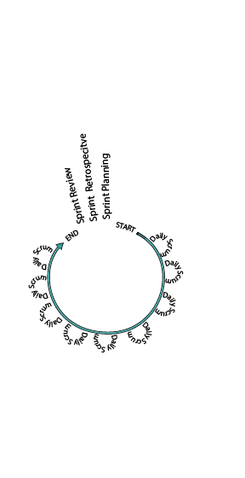

Figure 1 The Scrum Event Cycle